SAME Conference 26

GET YOUR FIX AT TWENTY SIX!

Saturday 14th September 2024, 9am – 4.30pm at Dollar Academy

ONLINE booking now open. Morning session £25, Afternoon session £25.
https://www.trybooking.com/uk/DTKB

With a history of successful live conferences (in the main at Stirling University) when music education colleagues from around Scotland (and further afield) gathered to listen to Presenters, learn from each other and look at exhibitions, SAME’s progress was thwarted with Covid and lockdowns, yet it was not knocked out.

Following a successful return to live conference-type events by holding a one-day event in September 2023, SAME now brings to you the 2024 event.

Situations in schools over colleague release and the paucity of CPD funding for large-scale events have guided SAME to continue to offer a weekend-based activity with a restriction on cost to delegates.

Saturday 14th September 2024 is our date with a return to Dollar Academy.

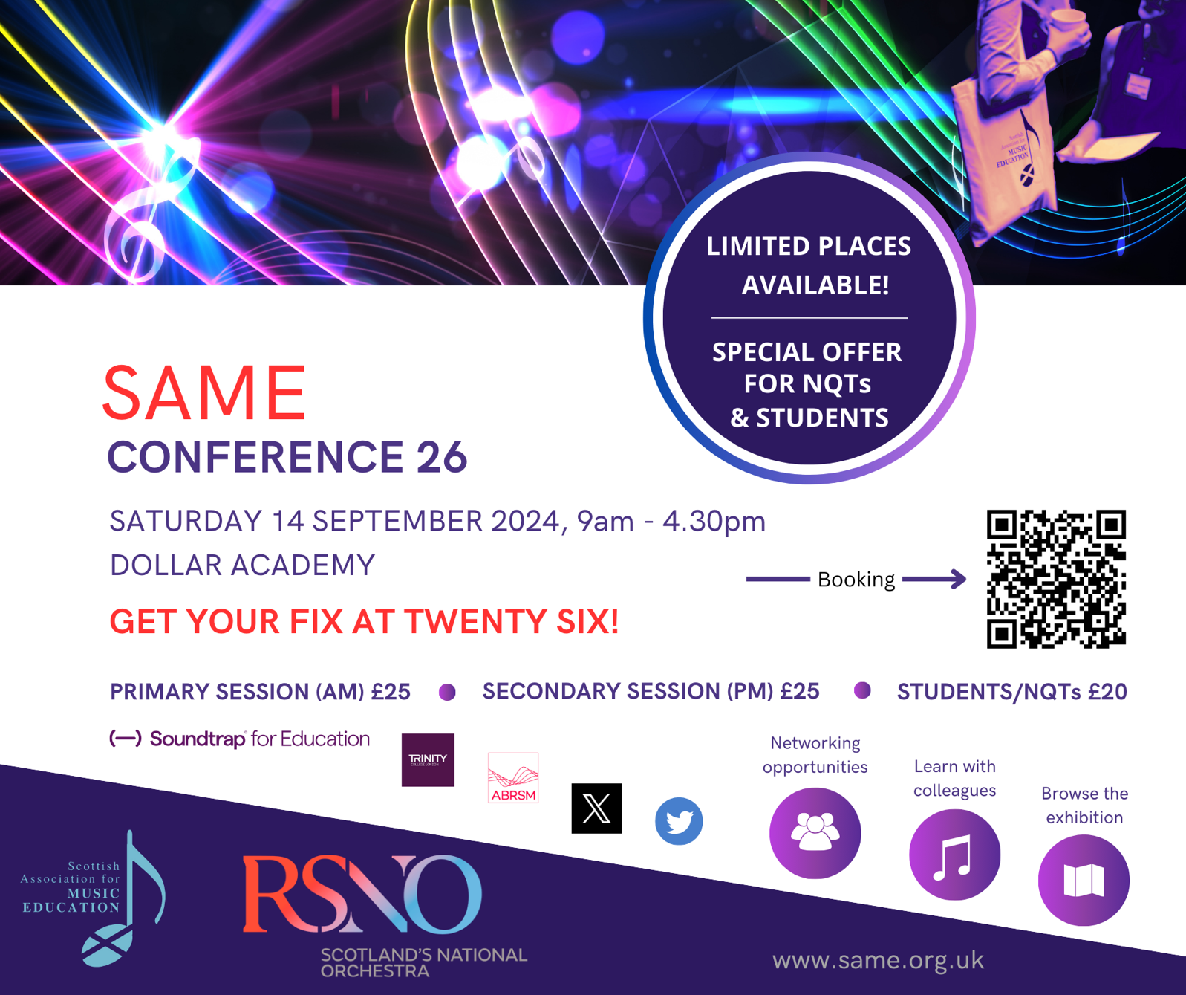

The morning is given over to a primary focus and the afternoon to a secondary one. At each session (morning and afternoon), there are three options and two time-slots. Delegates will choose two one-hour options with the bonus of a full and lively opening session to inspire all. Taking account of the music spaces at Dollar, there is a limit on delegates to around 30 per option thus a population of c.90 in the morning and a different c.90 in the afternoon. A small exhibition will complement the day’s activities.

HURRY, HURRY, HURRY – book now for a live, face-to-face SAME CPD opportunity. Meet up with old friends, make new ones. Make that connection and find support in abundance.

View the Conference 26 brochure here:
https://drive.google.com/drive/folders/1xL5FEr-P5RAw4_JKUteDUQssz4N6puUG?usp=sharing

Click here to make a booking:
https://www.trybooking.com/uk/DTKB

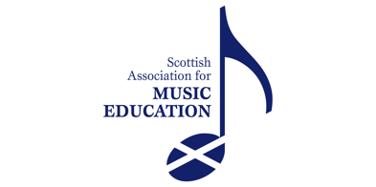
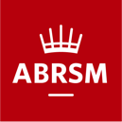
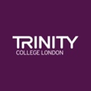
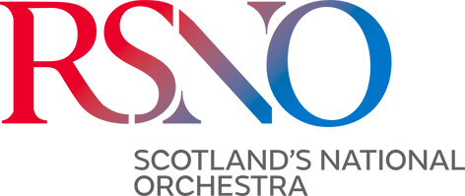
For further information contact:

SAME
c/o Graeme Wilson (Secretary)
Scottish Association for Music Education
PO Box 26858
Kirkcaldy
Fife
KY2 9BP

Email: samescotland@gmail.com

